# PROBLEMA 1

## Black-Box

A

B

Pulsos

S

Circuito secuencial para la contraseña (AABA) de una caja fuerte

## Diagrama de estados

## No. Y tipo de Flip-Flops

## Asignación de valores a los estados

|  |  |  |
| --- | --- | --- |
| Estado | QB | QA |
| S0 | 0 | 0 |
| S1 | 0 | 1 |
| S2 | 1 | 0 |
| S3 | 1 | 1 |

## Tabla de excitación

|  |  |  |  |  |  |  |  |  |
| --- | --- | --- | --- | --- | --- | --- | --- | --- |
| Entrada | Estado presente | | Estado siguiente | | B | | A | |
| **QB** | **QA** | **QB+1** | **QA+1** | **JB** | **KB** | **JA** | **KA** |
| 0 | 0 | 0 | 0 | 0 | 0 | X | 0 | X |
| 0 | 0 | 1 | 0 | 0 | 0 | X | X | 1 |
| 0 | 1 | 0 | 1 | 1 | X | 0 | 1 | X |
| 0 | 1 | 1 | 0 | 0 | X | 1 | X | 1 |
| 1 | 0 | 0 | 0 | 1 | 0 | X | 1 | X |
| 1 | 0 | 1 | 1 | 0 | 1 | X | X | 1 |
| 1 | 1 | 0 | 0 | 0 | X | 1 | 0 | X |
| 1 | 1 | 1 | 0 | 0 | X | 1 | X | 1 |

## Articulación Algebraica

* JB = QA * Entrada

|  |  |  |  |  |
| --- | --- | --- | --- | --- |
| QA\ Entrada QB | 00 | 01 | 11 | 10 |
| 0 | 0 | X | X | 0 |
| 1 | 0 | X | X | 1 |

* KB = QA + Entrada

|  |  |  |  |  |
| --- | --- | --- | --- | --- |
| QA\ Entrada QB | 00 | 01 | 11 | 10 |
| 0 | X | 0 | 1 | X |
| 1 | X | 1 | 1 | X |

* JA = (¬Entrada * QB) + (Entrada * ¬QB) = Entrada XOR QB

|  |  |  |  |  |
| --- | --- | --- | --- | --- |
| QA\ Entrada QB | 00 | 01 | 11 | 10 |
| 0 | 0 | 1 | 0 | 1 |
| 1 | X | X | X | X |

* KA = 1

|  |  |  |  |  |
| --- | --- | --- | --- | --- |
| QA\ Entrada QB | 00 | 01 | 11 | 10 |
| 0 | X | X | X | X |
| 1 | 1 | 1 | 1 | 1 |

## Diagrama Digital

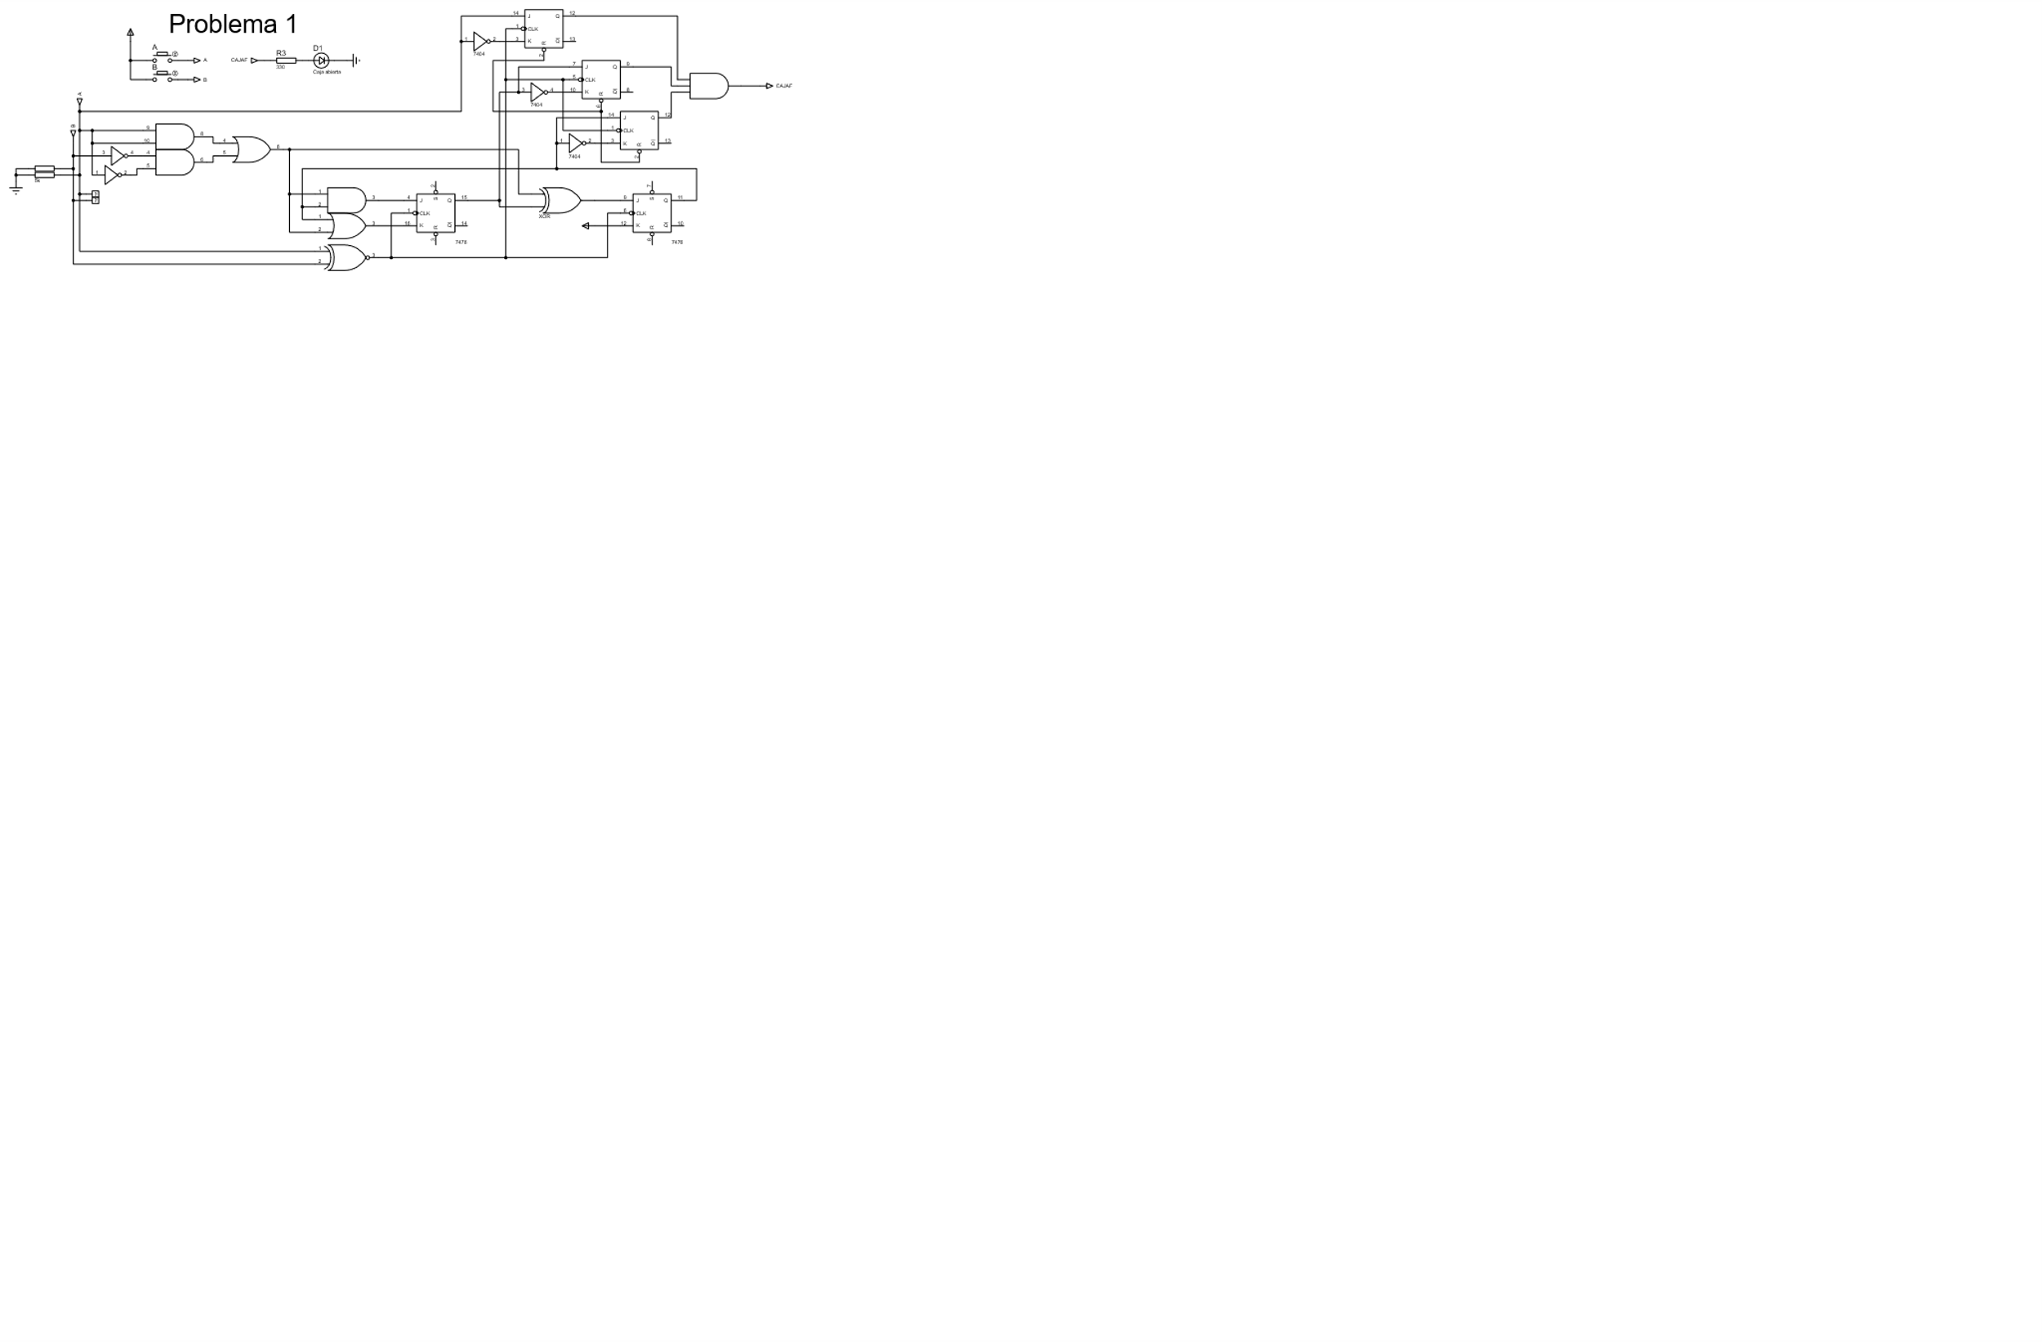

# PROBLEMA 2

## Black-Box

Reloj

DATA

S

Circuito para verificar que la entrada sea 1010

## Diagrama de estados

## No. Y tipo de Flip-Flops

## Asignación de valores a los estados

|  |  |  |
| --- | --- | --- |
| Estado | QB | QA |
| S0 | 0 | 0 |
| S1 | 0 | 1 |
| S2 | 1 | 0 |
| S3 | 1 | 1 |

## Tabla de excitación

|  |  |  |  |  |  |  |  |  |
| --- | --- | --- | --- | --- | --- | --- | --- | --- |
| Entrada | Estado presente | | Estado siguiente | | B | | A | |
| **QB** | **QA** | **QB+1** | **QA+1** | **JB** | **KB** | **JA** | **KA** |
| 0 | 0 | 0 | 0 | 0 | 0 | X | 0 | X |
| 0 | 0 | 1 | 1 | 0 | 1 | X | X | 1 |
| 0 | 1 | 0 | 0 | 0 | X | 1 | 0 | X |
| 0 | 1 | 1 | 0 | 0 | X | 1 | X | 1 |
| 1 | 0 | 0 | 0 | 1 | 0 | X | 1 | X |
| 1 | 0 | 1 | 0 | 0 | 0 | X | X | 1 |
| 1 | 1 | 0 | 1 | 1 | X | 0 | 1 | X |
| 1 | 1 | 1 | 0 | 0 | X | 1 | X | 1 |

## Articulación Algebraica

* JB = QA * ¬Entrada

|  |  |  |  |  |
| --- | --- | --- | --- | --- |
| QA\ Entrada QB | 00 | 01 | 11 | 10 |
| 0 | 0 | X | X | 0 |
| 1 | 1 | X | X | 0 |

* KB = QA + ¬Entrada

|  |  |  |  |  |
| --- | --- | --- | --- | --- |
| QA\ Entrada QB | 00 | 01 | 11 | 10 |
| 0 | X | 1 | 0 | X |
| 1 | X | 1 | 1 | X |

* JA = Entrada

|  |  |  |  |  |
| --- | --- | --- | --- | --- |
| QA\ Entrada QB | 00 | 01 | 11 | 10 |
| 0 | 0 | 0 | 1 | 1 |
| 1 | X | X | X | X |

* KA = 1

|  |  |  |  |  |
| --- | --- | --- | --- | --- |
| QA\ Entrada QB | 00 | 01 | 11 | 10 |
| 0 | X | X | X | X |
| 1 | 1 | 1 | 1 | 1 |

## Diagrama Digital

